**Storage Virtualization**

In Computer Science **Storage Virtualization** is “the process of presenting a logical view of the physical storage resource to” a host computer system. Treating all storage media as a single pool of storage.

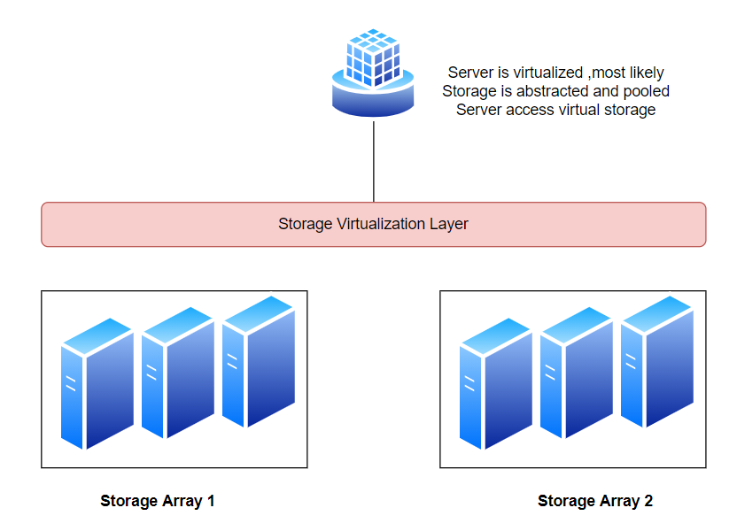

**Why we need Storage Virtualization?**

Difficult to manage physical storage.

Improves business demands , agility and scalability.

Traditional Storage is costly and occupies space

You don’t have to think about actual database distribution No need to think about RAID Configuration. Give your time in development or business logic rather than thinking of storage management.

Provides higher availability.

Storage Virtualization improves business agility

**SAN (Storage Area Network)🡪** A Storage Area Network is a dedicated , independent high speed network that interconnects and delivers shared pools of storage device to multiple server

SAN provides an architectural framework that enables IT Managers to connect remote storage devices to server in such a way that devices seems to be locally attached.

**Difference between SAN and VSAN ?**

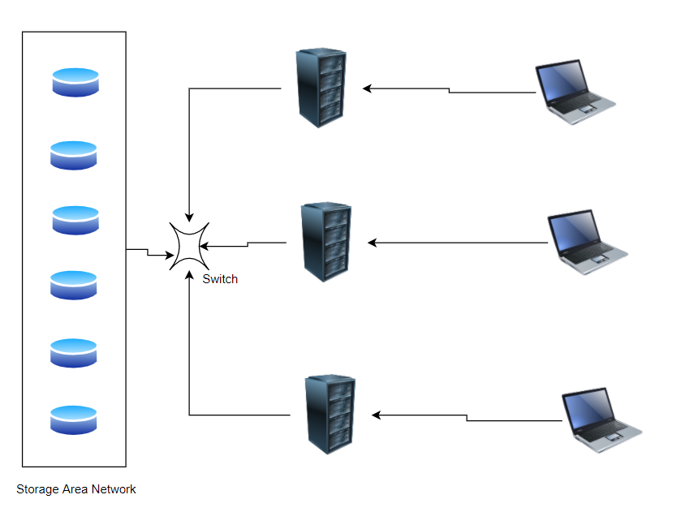

This is SAN where we have spate Storage pool and each server is sharing that space.

In vSAN a software layer sits between physical storage and provides an abstracted version of underlying physical storage.

Although traditional SAN and vSAN technology share many characteristics, vSAN doesn’t require external networked storage to remotely store virtual machine files. vSAN only work with ESXi hosts, while SAN leverages storage protocols such as FCP and iSCSI.

Lastly, organizations use SANs to interconnect shared pools of storage devices to different servers. vSAN extends this local storage to a shareable storage in each server, enabling other servers to access data over the LAN without a traditional shared storage device.